**Project Report: PLC Lab Trainer Boxes**

**To:** Sean McBride

**From:** Ben Anderson

**Date:** 6-27-2025

## Summary

This report details the development of two distinct **PLC lab trainer boxes**: a **general I/O and heater control box** and a **motor control box**. These trainers are designed to provide a hands-on learning platform for industrial automation concepts, integrating with standard industrial signals and PLC inputs/outputs.  
More detailed documentation for the whole project is in development to cover all aspects of the project. This summary provides a basic overview and an update on the accomplishments this year.

## General I/O and Process Control Lab Trainer Box

This trainer box builds upon the existing design used in the 1181 class, focusing on practical process control. It includes:

* **General I/O:** Buttons, lights, a potentiometer, and a voltmeter for basic input/output exercises.
* **Process Control Elements:**
  + A relay to power a resistor, functioning as a small **heater**.
  + A simple **thermocouple with a transmitter** to provide temperature feedback.
  + A **fan** to dissipate heat, providing a controllable load on the heater.

Minimal development was required for this box, primarily involving the specification and procurement of parts.

## Motor Control Lab Trainer Box

The motor control box introduces a key innovation: a **motor control board** that enables a PLC to control low-cost DC motors using standard industrial signals.

**Key Innovations and Components:**

* **Custom Motor Control Board:** Allows PLCs to interface with affordable DC motors.
  + **Raspberry Pi Pico:** Utilized to read encoder data and generate the necessary feedback signals for the PLC.
  + **Simple interface:** standard 0-10v signal can be used to control speed or optionally, PWM can also be used. Speed and Position feedback is provided using 0-10v signals.
* **Encoders:** Integrated with motors to provide crucial **speed and position feedback**.

## Pi Pico Quadrature Encoder Interface: Code Overview

The core of the motor control box is the custom firmware developed for the Raspberry Pi Pico, which implements a robust quadrature encoder interface. This code facilitates the integration of small DC brushed motors with PLCs for educational applications.

**Purpose and Key Functionality:**

The primary goal of this code is to provide an accessible platform for learning industrial motor control. It achieves this by:

* **Industrial Signal Compatibility:** Handling standard 0-10V analog inputs for speed commands and generating 0-10V analog outputs for speed and position feedback.
* **Motor Control & Feedback:** Reading quadrature encoder signals from both 775 and gear motors to provide real-time position and speed feedback.
* **Position Control:** position is provided within 1 revolution and within 10 revolutions for broader control. A home switch can be incorporated to allow simple homing of the motor controllable by the PLC, or the position can be zeroed by the PLC.
* **Efficient Encoder Reading:** Utilizing a dedicated PIO (Programmable I/O) program on the Pico to efficiently sample encoder phases, maintain a 32-bit position counter at high speeds (up to sysclk/10).

**Signal Interface Highlights:**

The Pico firmware processes PLC inputs (Speed Command, Home Command, Motor Selection) and generates PLC outputs (Speed Feedback, Position Feedback, 10x Position Feedback, Direction Feedback), facilitating communication between the motor control board and a PLC.

## Previous Work (Spring/Summer 2024)

* The **heater box design** is based on an existing lab box used for the 1181 class, requiring minimal new development beyond part specification and procurement.
* A **motor control board version 0** was successfully built and tested in Summer 2024.
* Pico encoder reading and output functions were successfully **breadboarded**, and Tim R. developed an initial PCB design.

## Accomplishments This Spring/Summer 2025

* **PCB Prototyping:** Built two PCBs designed by Tim R. and Tim L. – one for the v1 H-bridge motor control and another for the Pico encoder interface. Both boards functioned successfully.
* **Integrated Board Development:** Combined the two prototype designs into a single, integrated board to house all motor control functions.
* **Surface Mount Technology (SMT):** Utilized JLCPCB for populating surface mount components on the new integrated board, significantly reducing manual soldering effort for testing.
* **Heater Box Construction:** Directed Justin in the construction of the heater control boxes.
* **DB37 Adapter Card:** Finalized the design of the DB37 adapter card created by Carlos and ordered sufficient quantities to complete the project.

## Combined Board design:

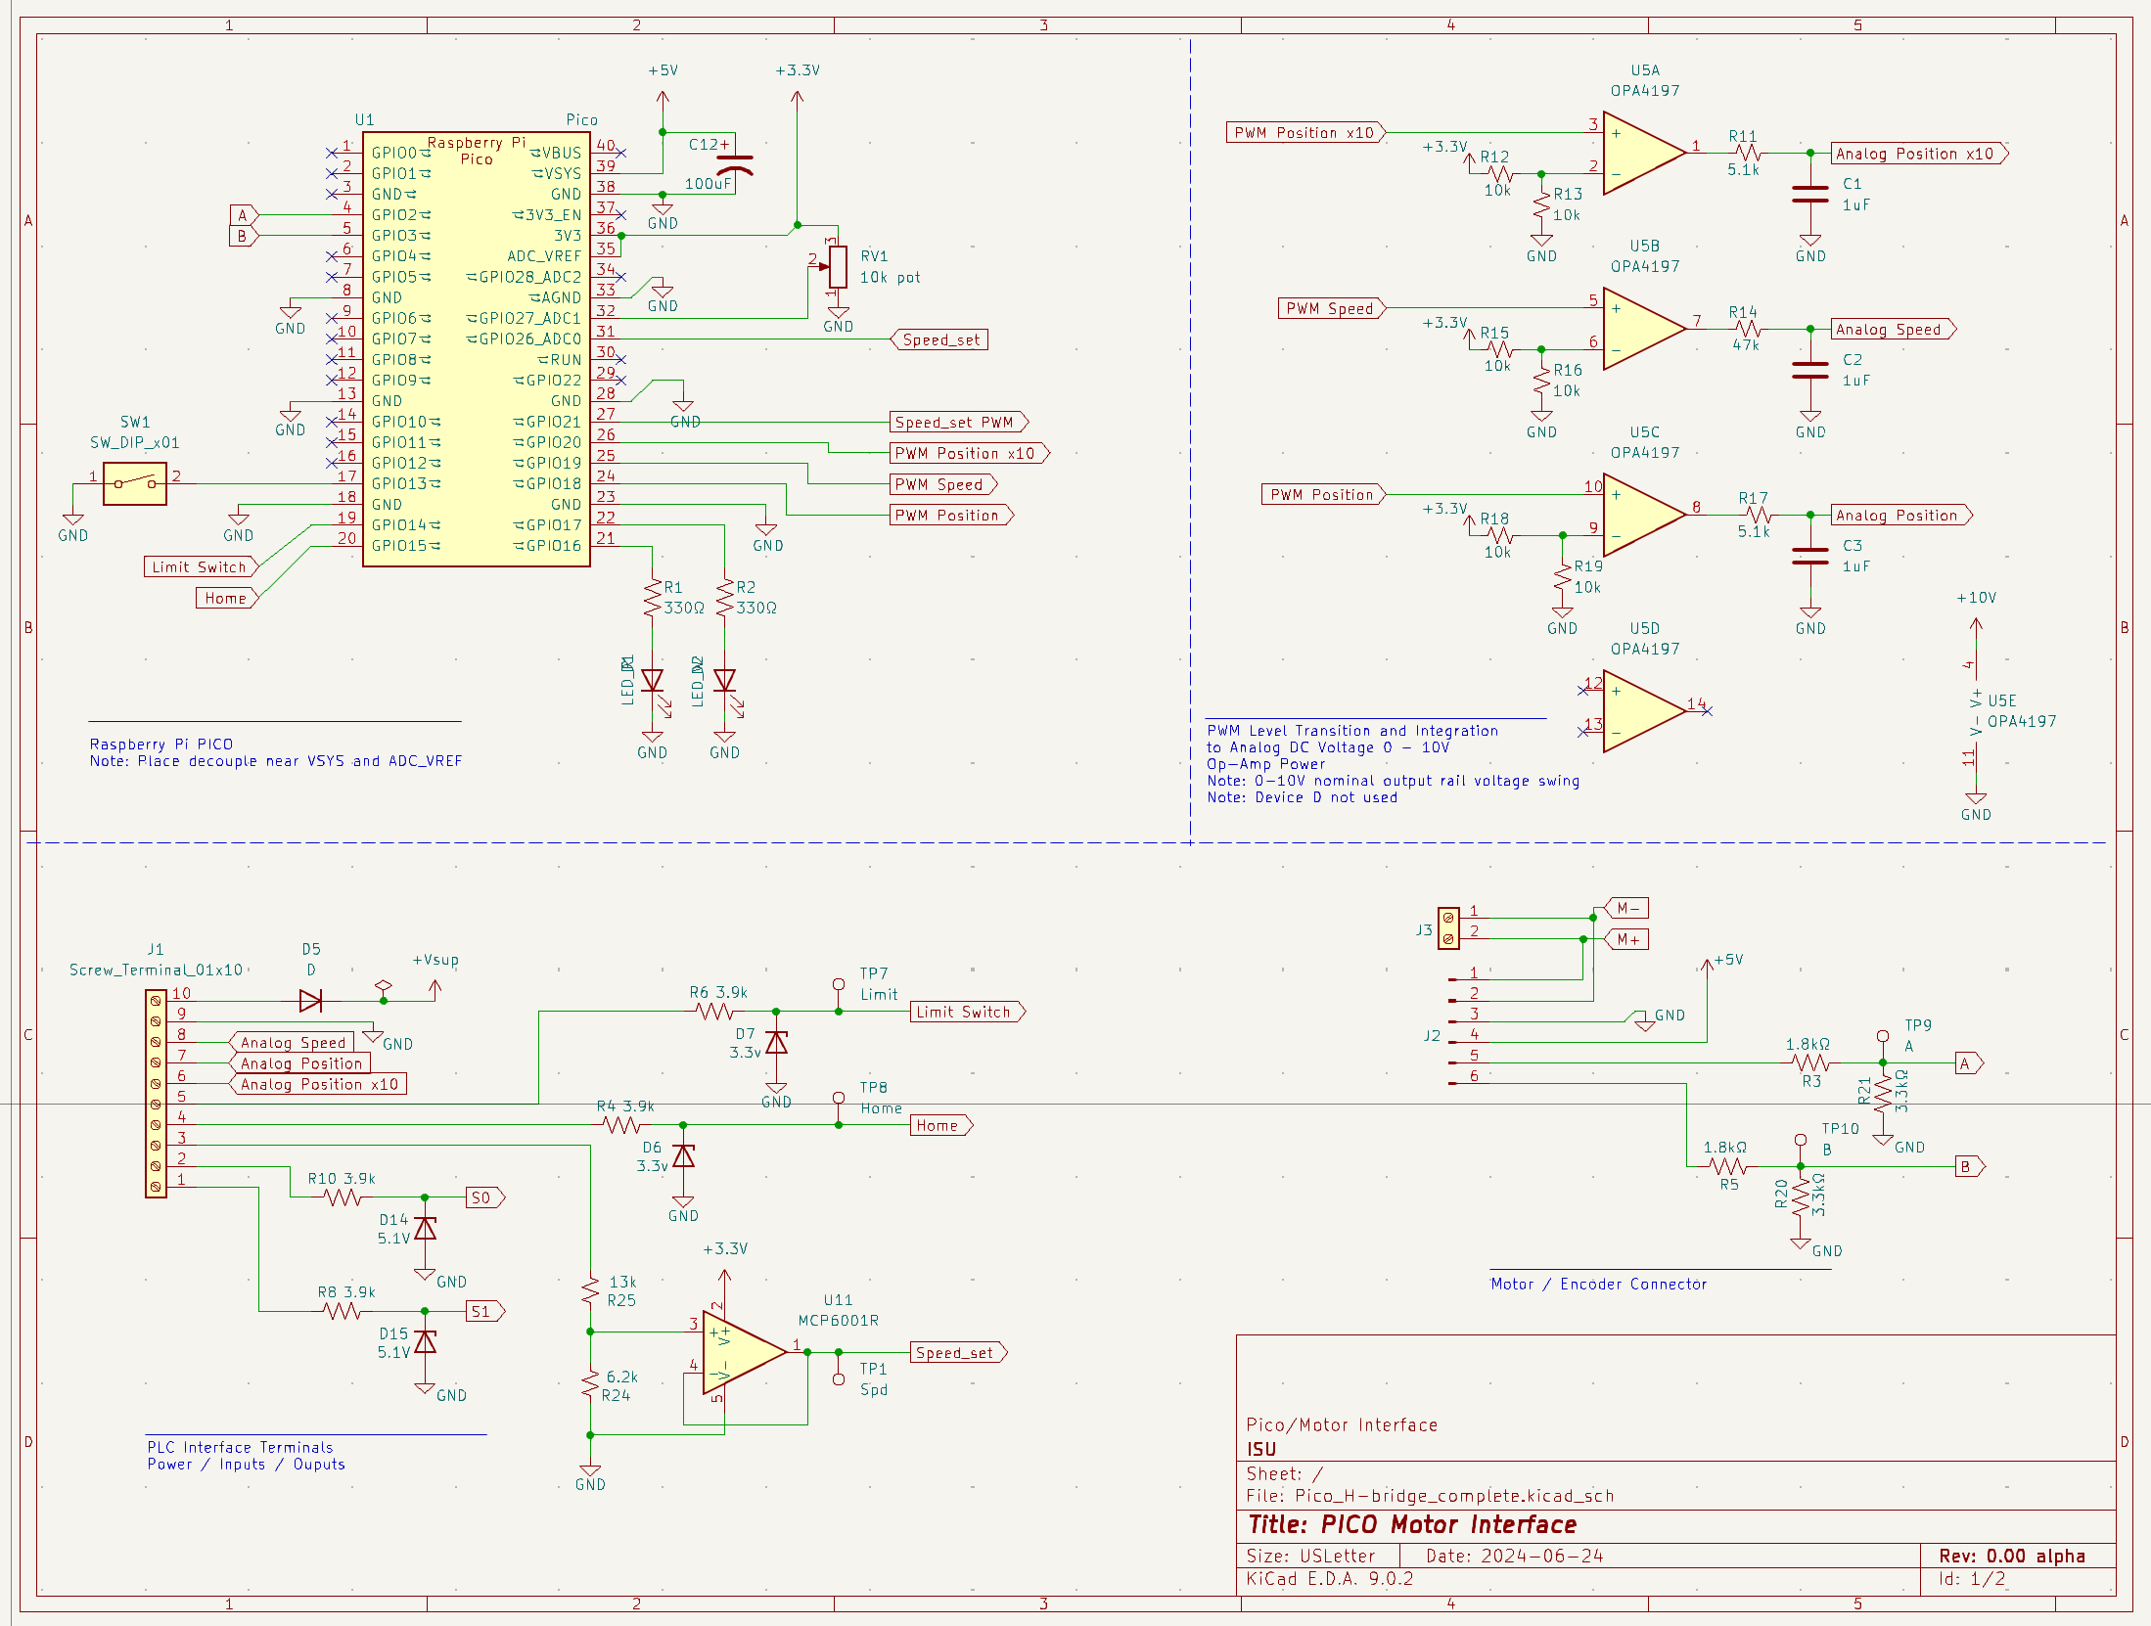

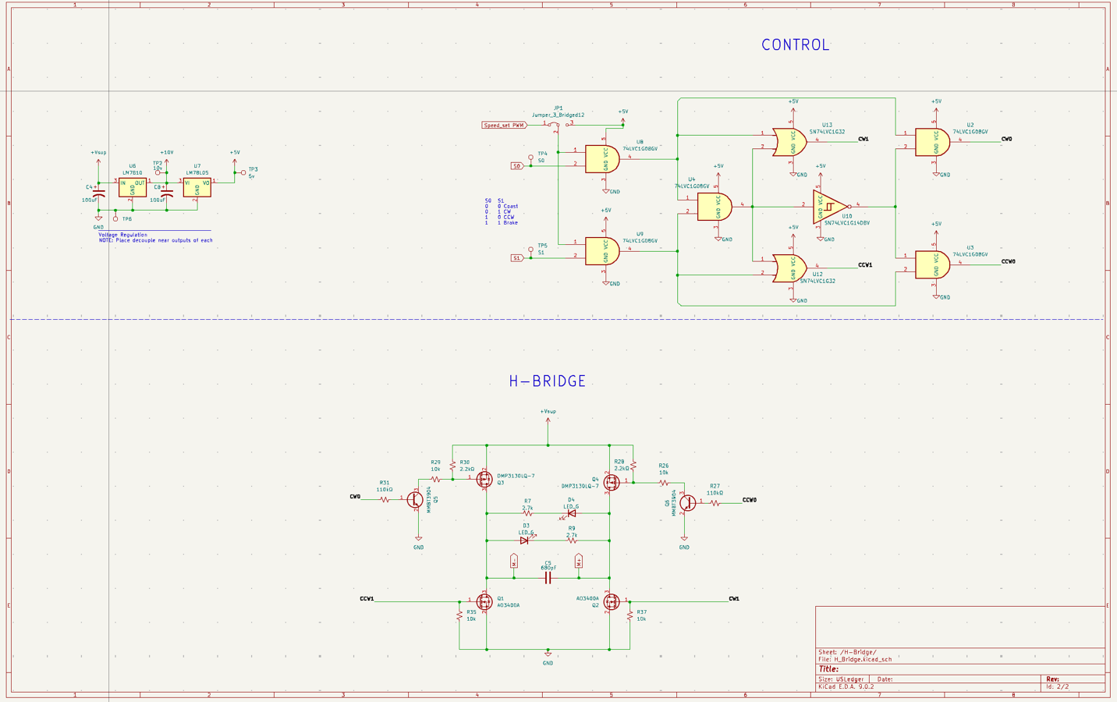

### PCB Layout:

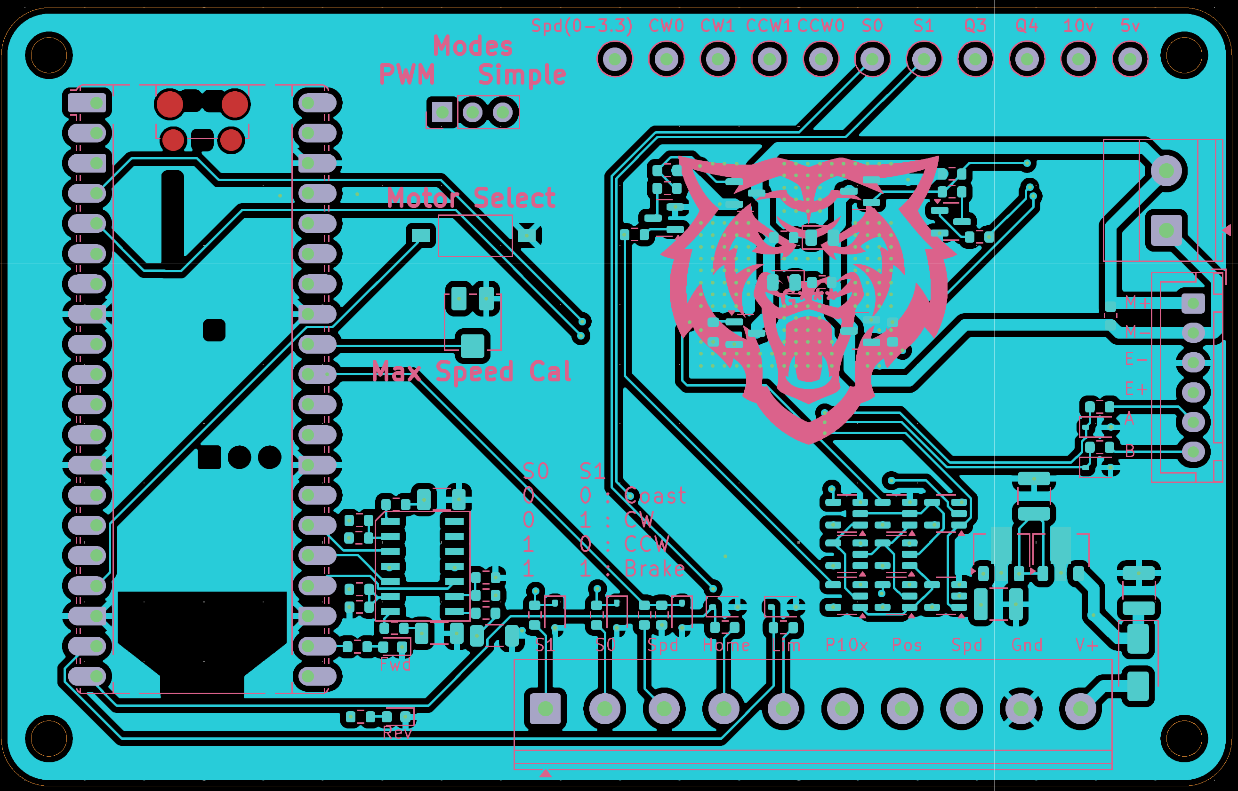

### First integrated board post production:

### 